**Check failed back-ups last three weeks to determine failures that occur more than once in a row.**

1. Sign into Azure portal and go to virtual machines

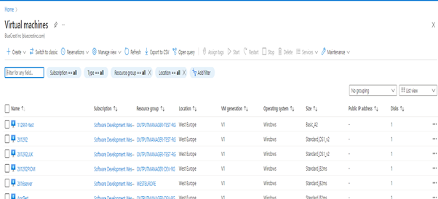

Check if server is managed by atos by filtering out with backup policy

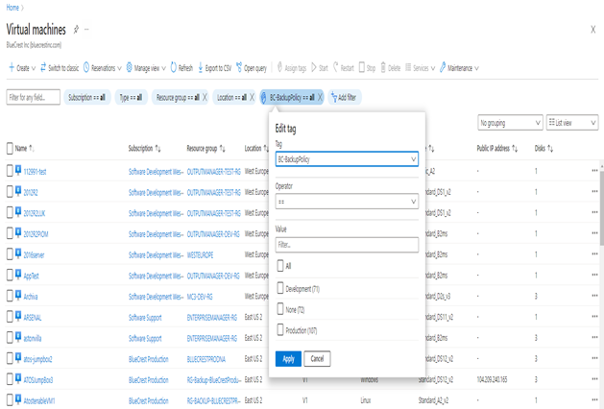

Go to server and check if backup is enabled

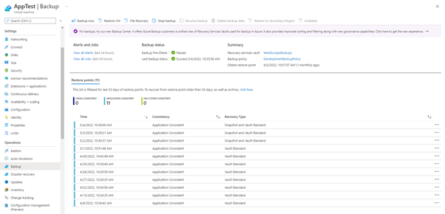

Go to View all jobs and filter out three weeks of time

